TABLE OF CONTENTS

S.No. | Contents | Page No.
1 | Lab Rules | 2
2 | Instructions | 4
3 | Zero Lab | 5
4 | Syllabus | 7
5 | Marks Scheme | 8
6 | Lab Plan | 9
7 | Introduction to the subject | 10
8 | Lab objective | 11
9 | Experiments | 12
10 | Resources

LAB RULES

Responsibilities of Users
Users are expected to follow some fairly obvious rules of conduct:

 Always:

  - Enter the lab on time and leave at proper time.
  - Wait for the previous class to leave before the next class enters.
  - Keep the bag outside in the respective racks.
  - Utilize lab hours in the corresponding.
  - Turn off the machine before leaving the lab unless a member of lab staff has specifically told you not to do so.
  - Leave the labs at least as nice as you found them.
  - If you notice a problem with a piece of equipment (e.g. a computer doesn't respond) or the room in general (e.g. cooling, heating, lighting) please report it to lab staff immediately. Do not attempt to fix the problem yourself.

 Never:

  - Don't abuse the equipment.
  - Do not adjust the heat or air conditioners. If you feel the temperature is not properly set, inform lab staff; we will attempt to maintain a balance that is healthy for people and machines.
  - Do not attempt to reboot a computer. Report problems to lab staff.
  - Do not remove or modify any software or file without permission.
  - Do not remove printers and machines from the network without being explicitly told to do so by lab staff.
  - Don't monopolize equipment. If you're going to be away from your machine for more than 10 or 15 minutes, log out before leaving. This is both for the security of your account, and to ensure that others are able to use the lab resources while you are not.
  - Don’t use internet, internet chat of any kind in your regular lab schedule.
  - Do not download or upload of MP3, JPG or MPEG files.
  - No games are allowed in the lab sessions.
  - No hardware including USB drives can be connected or disconnected in the labs without prior permission of the lab in-charge.
  - No food or drink is allowed in the lab or near any of the equipment. Aside from the fact that it leaves a mess and attracts pests, spilling anything on a keyboard or other piece of computer equipment could cause permanent, irreparable, and costly damage. (and in fact has) If you need to eat or drink, take a break and do so in the canteen.
  - Don’t bring any external material in the lab, except your lab record, copy and books.
  - Don’t bring the mobile phones in the lab. If necessary then keep them in silence mode.
  - Please be considerate of those around you, especially in terms of noise level. While labs are a natural place for conversations of all types, kindly keep the volume turned down.

If you are having problems or questions, please go to either the faculty, lab in-charge or the lab supporting staff. They will help you. We need your full support and cooperation for smooth functioning of the lab.
INSTRUCTIONS

Before entering in the lab

All the students are supposed to prepare the theory regarding the next experiment.
Students are supposed to bring the practical file and the lab copy.
Previous programs should be written in the practical file.
All the students must follow the instructions, failing which he/she may not be allowed in the lab.

While working in the lab

Adhere to experimental schedule as instructed by the lab in-charge.
Get the previously executed program signed by the instructor.
Get the output of the current program checked by the instructor in the lab copy.
Each student should work on his/her assigned computer at each turn of the lab.
Take responsibility of valuable accessories.
Concentrate on the assigned practical and do not play games
If anyone caught red handed carrying any equipment of the lab, then he/she will have to face serious consequences.

SYLLABUS
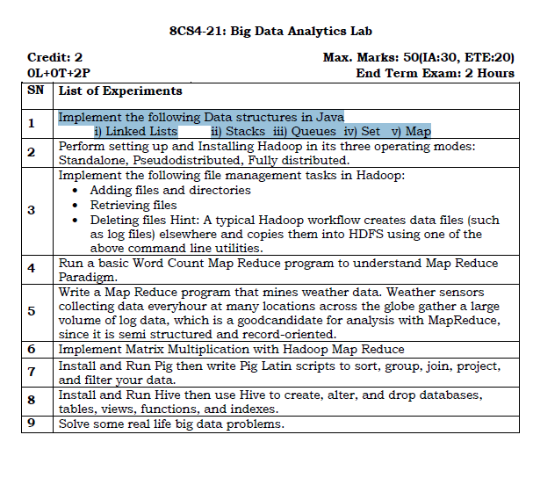
Software required

Hadoop
CloudEra

Introduction to the subject

This Subject gives an in-depth knowledge about Testing and Validation. This subject provides us the way to specify various testing technologies and tools, some of design strategies and many of fundamental ideas used in test case analysis.

Software project management, software testing, and software engineering, verification and validation is the process of checking that a software system meets specifications and requirements so that it fulfills its intended purpose. It may also be referred to as software quality control.

This subject is not important for a single lab but for all labs as all labs is concerned with testing the solution of a problem by programming and it is best way for verified programming and solving a problem.

Lab Objective

Objectives: Upon successful completion of this course, students should be able to:

- work with hadoop
- data analysis on various tools
- working on single node and multinode systems

A. It is expected that teachers will assign experiments to the students for testing. Problems and Test cases may be chosen by the teachers.

B. Problem on performing testing to meet required constraints may be assigned. For example, a problem on testing a web site for performance or coverage testing of program byte code.

Experiments

Experiment No.: 1
Name of Experiment: Implement the following Data structures in Java
i) Linked Lists ii) Stacks iii) Queues iv) Set v) Map
- Program Code: LINKED LIST
import java.util.*;
public class Test {
public static void main(String args[])
{
// Creating object of the
// class linked list
LinkedList<String>ll= new LinkedList<String>();
// Adding elements to the linked list
ll.add("A");
ll.add("B");
ll.addLast("C");
ll.addFirst("D");
ll.add(2, "E");
System.out.println(ll);

ll.remove("B");
ll.remove(3);
ll.removeFirst();
ll.removeLast();
System.out.println(ll);
}
}

Output :-

[D, A, E, B, C]
[A]

- STACK
import java.io.*;
import java.util.*;
class Test
{
// Pushing element on the top of the stack
static void stack_push(Stack<Integer> stack)
{
for(int i = 0; i< 5; i++)
{
stack.push(i);
}
}
// Popping element from the top of the stack
static void stack_pop(Stack<Integer> stack)
{
System.out.println("Pop Operation:");
for(int i = 0; i< 5; i++)
{
Integer y = (Integer) stack.pop();
System.out.println(y);
}
}
// Displaying element on the top of the stack
static void stack_peek(Stack<Integer> stack)
{
Integer element = (Integer) stack.peek();
System.out.println("Element on stack top: " + element);
}
// Searching element in the stack
static void stack_search(Stack<Integer> stack, int element)
{
Integer pos = (Integer) stack.search(element);

if(pos == -1)
System.out.println("Element not found");
else
System.out.println("Element is found at position: " + pos);
}
public static void main (String[] args)
{
Stack<Integer> stack = new Stack<Integer>();
stack_push(stack);
stack_pop(stack);
stack_push(stack);
stack_peek(stack);
stack_search(stack, 2);
stack_search(stack, 6);
}
}

Output :-

Pop Operation:
4
3
2
1
0
Element on stack top: 4
Element is found at position: 3
Element not found

- QUEUE
import java.util.LinkedList;
import java.util.Queue;
public class QueueExample {
public static void main(String[] args)
{
Queue<Integer> q= new LinkedList<>();
// Adds elements {0, 1, 2, 3, 4} to
// the queue
for (int i = 0; i< 5; i++)
q.add(i);

// Display contents of the queue.
System.out.println("Elements of queue "+ q);

// To remove the head of queue.
int removedele = q.remove();
System.out.println("removed element-"+ removedele);
System.out.println(q);

// To view the head of queue
int head = q.peek();
System.out.println("head of queue-"+ head);
int size = q.size();
System.out.println("Size of queue-"+ size);
}
}

Output :-
Elements of queue [0, 1, 2, 3, 4]
removed element-0
[1, 2, 3, 4]
head of queue-1
Size of queue-4

- SET
import java.util.*;
public class setExample{
public static void main(String[] args)
{
// creating LinkedHashSet using the Set
Set<String> data = new LinkedHashSet<String>();

data.add("Implementing");
data.add("Set");
data.add("Example");

System.out.println(data);
}
}

Output :-

[Implementing, Set, Example]

- MAP
import java.util.*;
class HashMapDemo {
public static void main(String args[])
{
Map<String, Integer> hm= new HashMap<String, Integer>();

hm.put("a", new Integer(100));
hm.put("b", new Integer(200));
hm.put("c", new Integer(300));
hm.put("d", new Integer(400));

// Traversing through the map
for (Map.Entry<String, Integer>me :hm.entrySet()) {
System.out.print(me.getKey() + ":");
System.out.println(me.getValue());
}
}
}

Experiment No.: 2
Name of Experiment: Perform setting up and Installing Hadoop in its three operating modes:
Standalone, Pseudodistributed, Fully distributed.
Steps to perform Experiment:

Downloading and Installing the Cloudera VM Instructions (Windows)

Learning Goals
In this activity, you will:
- Download and Install VirtualBox.
- Download and Install Cloudera Virtual Machine (VM) Image.
- Launch the Cloudera VM.
Hardware Requirements: (A) Quad Core Processor (VT-x or AMD-V support recommended), 64-bit; (B) 8 GB RAM; (C) 20 GB disk free. How to find your hardware information: Open System by clicking the Start button, right-clicking Computer, and then clicking Properties. Most computers with 8 GB RAM purchased in the last 3 years will meet the minimum requirements.You will need a high speed internet connection because you will be downloading files up to 4 Gb in size.
Instructions
Please use the following instructions to download and install the ClouderaQuickstart VM with VirutalBox before proceeding to the Getting Started with the Cloudera VM Environment video. The screenshots are from a Mac but the instructions should be the same for Windows. Please see the discussion boards if you have any issues.
1. Install VirtualBox. Go to https://www.virtualbox.org/wiki/Downloads to download and install VirtualBox for your computer. The course uses Virtualbox 5.1.X, so we recommend clicking VirtualBox 5.1 builds on that page and downloading the older package for ease of following instructions and screenshots. However, it shouldn't be too different if you choose to use or upgrade to VirtualBox 5.2.X. For Windows, select the link "VirtualBox 5.1.X for Windows hosts x86/amd64" where 'X' is the latest version.
2. Download the Cloudera VM. Download the Cloudera VM fromhttps://downloads.cloudera.com/demo_vm/virtualbox/cloudera-quickstart-vm-5.4.2-0-virtualbox.zip. The VM is over 4GB, so will take some time to download.
3. Unzip the Cloudera VM:
Right-click cloudera-quickstart-vm-5.4.2-0-virtualbox.zip and select “Extract All…”
4. Start VirtualBox.
5. Begin importing. Import the VM by going to File -> Import Appliance
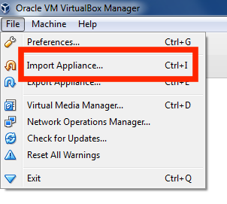
6. Click the Folder icon.
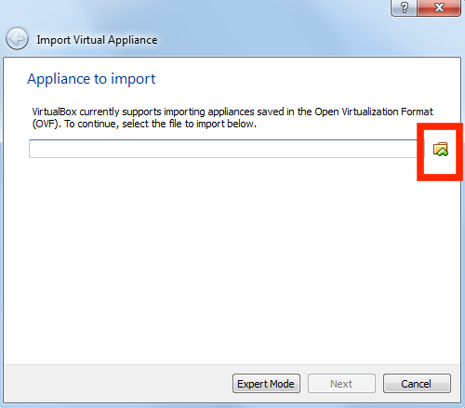
7. Select the cloudera-quickstart-vm-5.4.2-0-virtualbox.ovf from the Folder where you unzipped the VirtualBox VM and click Open.
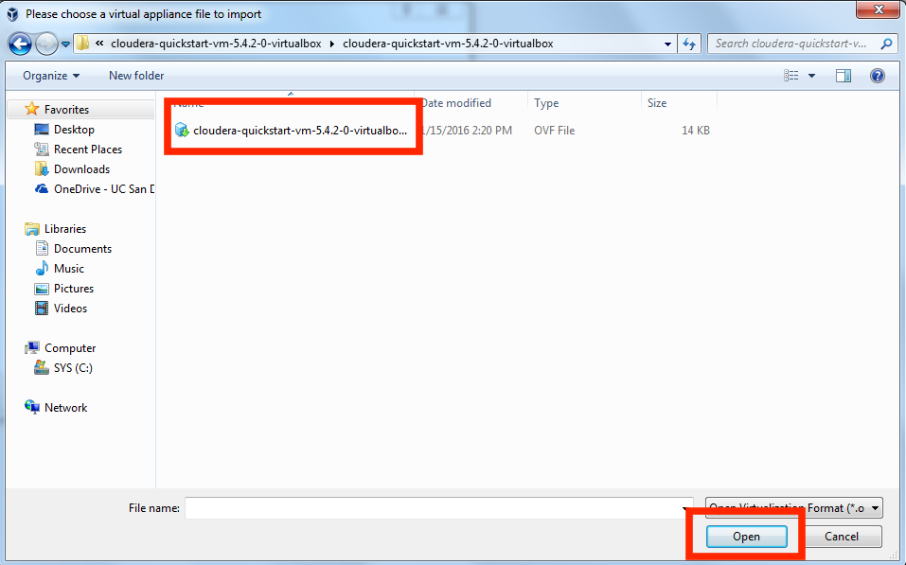
8. Click Next to proceed.
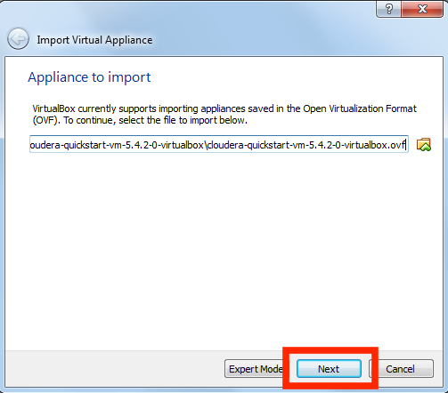

9. Click Import.
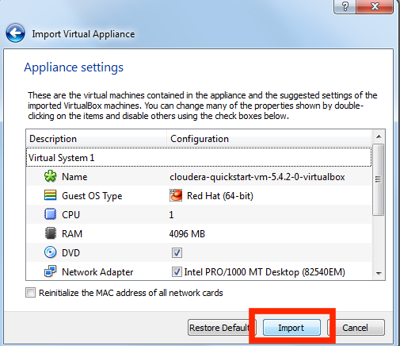
10. The virtual machine image will be imported. This can take several minutes.
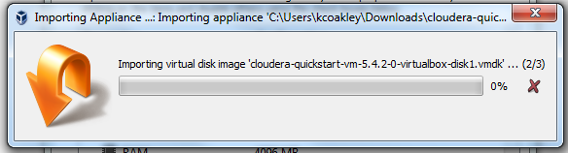

11. Launch Cloudera VM. When the importing is finished, the quickstart-vm-5.4.2-0 VM will appear on the left in the VirtualBox window. Select it and click the Start button to launch the VM.
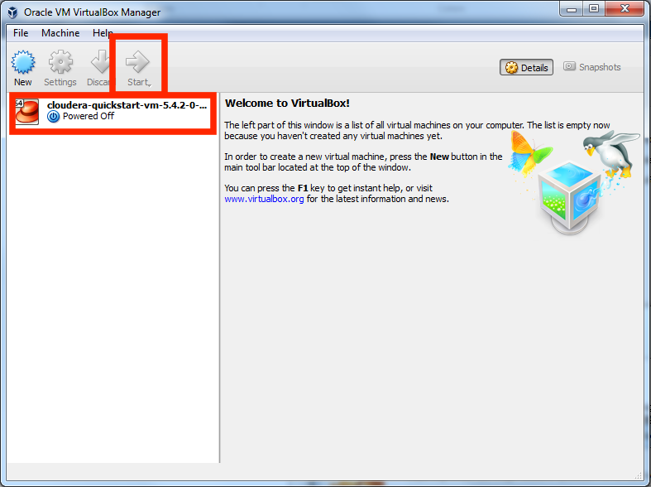

12. Cloudera VM booting. It will take several minutes for the Virtual Machine to start. The booting process takes a long time since many Hadoop tools are started.
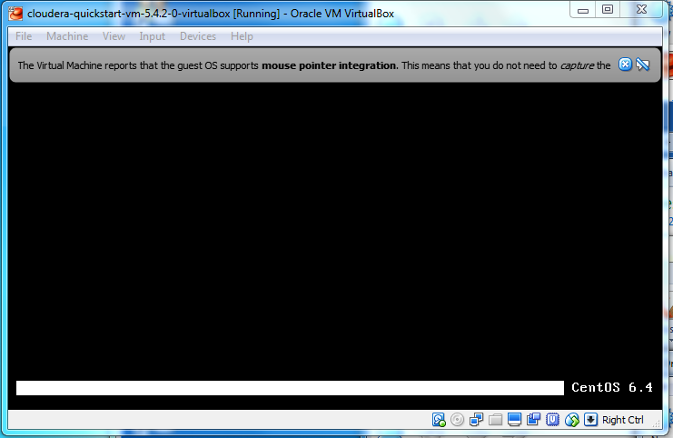
13. The Cloudera VM desktop. Once the booting process is complete, the desktop will appear with a browser.
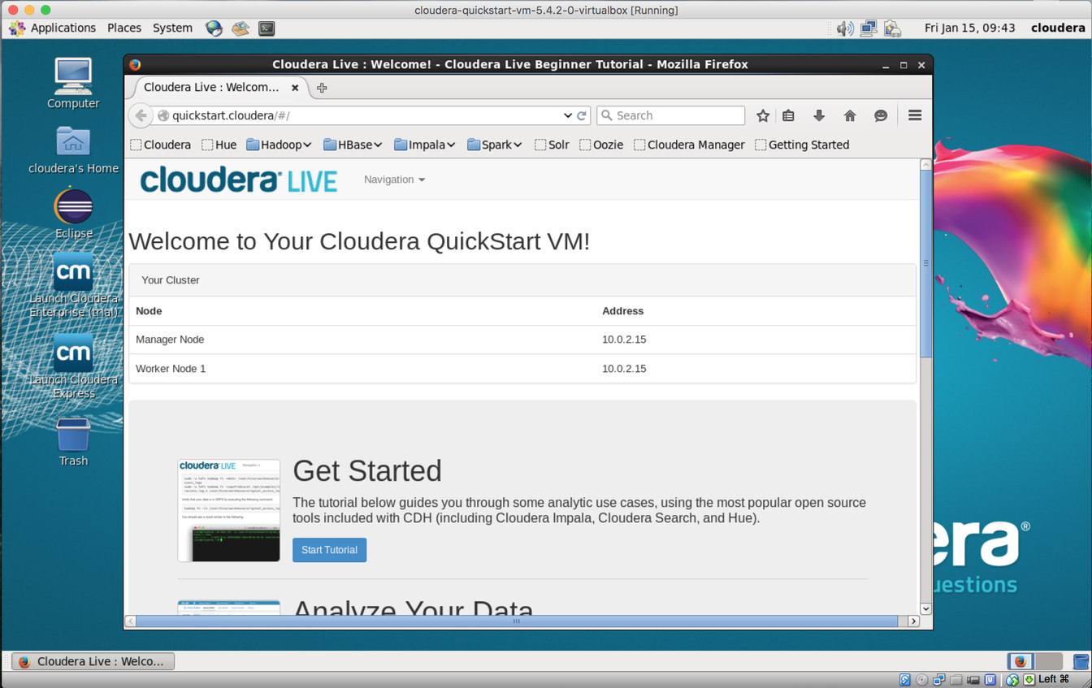

Way-2
Hadoop installation on UBUNTU
Step by step procedure for HADOOP installation on UBUNTU

Open terminal in UBUNTU and execute the fallowing commands one by one

1)sudo apt update

2)sudo apt install openjdk-8-jdk -y

3)java -version; javac -version

4)sudo apt install openssh-server openssh-client -y

5)ssh-keygen -t rsa -P '' -f ~/.ssh/id_rsa

6)cat ~/.ssh/id_rsa.pub >> ~/.ssh/authorized_keys

7)chmod 0600 ~/.ssh/authorized_keys

8)ssh localhost

9)wget https://downloads.apache.org/hadoop/common/hadoop-3.2.1/hadoop-3.2.1.tar.gz

10)tar xzf hadoop-3.2.1.tar.gz

11)sudo nano .bashrc

#Hadoop Related Options
export HADOOP_HOME=/home/hadoop-3.2.1
export HADOOP_INSTALL=$HADOOP_HOME
export HADOOP_MAPRED_HOME=$HADOOP_HOME
export HADOOP_COMMON_HOME=$HADOOP_HOME
export HADOOP_HDFS_HOME=$HADOOP_HOME
export YARN_HOME=$HADOOP_HOME
export HADOOP_COMMON_LIB_NATIVE_DIR=$HADOOP_HOME/lib/native
export PATH=$PATH:$HADOOP_HOME/sbin:$HADOOP_HOME/bin
export HADOOP_OPTS=”-Djava.library.path=$HADOOP_HOME/lib/native”

12)source ~/.bashrc

13)sudo nano $HADOOP_HOME/etc/hadoop/hadoop-env.sh

export JAVA_HOME=/usr/lib/jvm/java-8-openjdk-amd64

which javac

readlink -f /usr/bin/javac

14)sudo nano $HADOOP_HOME/etc/hadoop/core-site.xml

<configuration>
<property>
<name>hadoop.tmp.dir</name>
<value>/home/tmpdata</value>
</property>
<property>
<name>fs.default.name</name>
<value>hdfs://127.0.0.1:9000</value>
</property>
</configuration>

15)sudo nano $HADOOP_HOME/etc/hadoop/hdfs-site.xml

<configuration>
<property>
<name>dfs.data.dir</name>
<value>/home/dfsdata/namenode</value>
</property>
<property>
<name>dfs.data.dir</name>
<value>/home/dfsdata/datanode</value>
</property>
<property>
<name>dfs.replication</name>
<value>1</value>
</property>
</configuration>

16)sudo nano $HADOOP_HOME/etc/hadoop/mapred-site.xml

<configuration>
<property>
<name>mapreduce.framework.name</name>
<value>yarn</value>
</property>
</configuration>

17)sudo nano $HADOOP_HOME/etc/hadoop/yarn-site.xml
<configuration>
<property>
<name>yarn.nodemanager.aux-services</name>
<value>mapreduce_shuffle</value>
</property>
<property>
<name>yarn.nodemanager.aux-services.mapreduce.shuffle.class</name>
<value>org.apache.hadoop.mapred.ShuffleHandler</value>
</property>
<property>
<name>yarn.resourcemanager.hostname</name>
<value>127.0.0.1</value>
</property>
<property>
<name>yarn.acl.enable</name>
<value>0</value>
</property>
<property>
<name>yarn.nodemanager.env-whitelist</name>
<value>JAVA_HOME,HADOOP_COMMON_HOME,HADOOP_HDFS_HOME,HADOOP_CONF_DIR,CLASSPATH_PERPEND_DISTCACHE,HADOOP_YARN_HOME,HADOOP_MAPRED_HOME</value>
</property>
</configuration>

18)hdfs namenode -format

Navigate to the hadoop-3.2.1/sbin directory

19)./start-dfs.sh

20)./start-yarn.sh

21)jps

22)http://localhost:9870

23)http://localhost:9864

24)http://localhost:8088

Experiment No.: 3
Name of Experiment:
Implement the following file management tasks in Hadoop:
• Adding files and directories
• Retrieving files
• Deleting files Hint: A typical Hadoop workflow creates data files (such
as log files) elsewhere and copies them into HDFS using one of the
above command line utilities.
Steps to perform Experiment:
Adding Files and Directories
hadoop fs -mkdir /user/lakshya
hadoop fs -put
hadoop fs -put example.txt /user/lakshya

Retrieving Files
hadoop fs -cat example.txt

Deleting files
hadoop fs -rm example.txt

Experiment No.: 4
Name of Experiment: Run a basic Word Count Map Reduce program to understand Map Reduce
Paradigm.
Steps to perform Experiment:

Run the Word Count program Instructions

Learning Goals
By the end of this activity, you will be able to:
- Execute the WordCount application.
- Copy the results from WordCount out of HDFS.
- Open a terminal shell. Start the Cloudera VM in VirtualBox, if not already running, and open a terminal shell. Detailed instructions for these steps can be found in the previous Readings.
2. See example MapReduce programs. Hadoop comes with several example MapReduce applications. You can see a list of them by running hadoop jar /usr/jars/hadoop-examples.jar. We are interested in running WordCount.
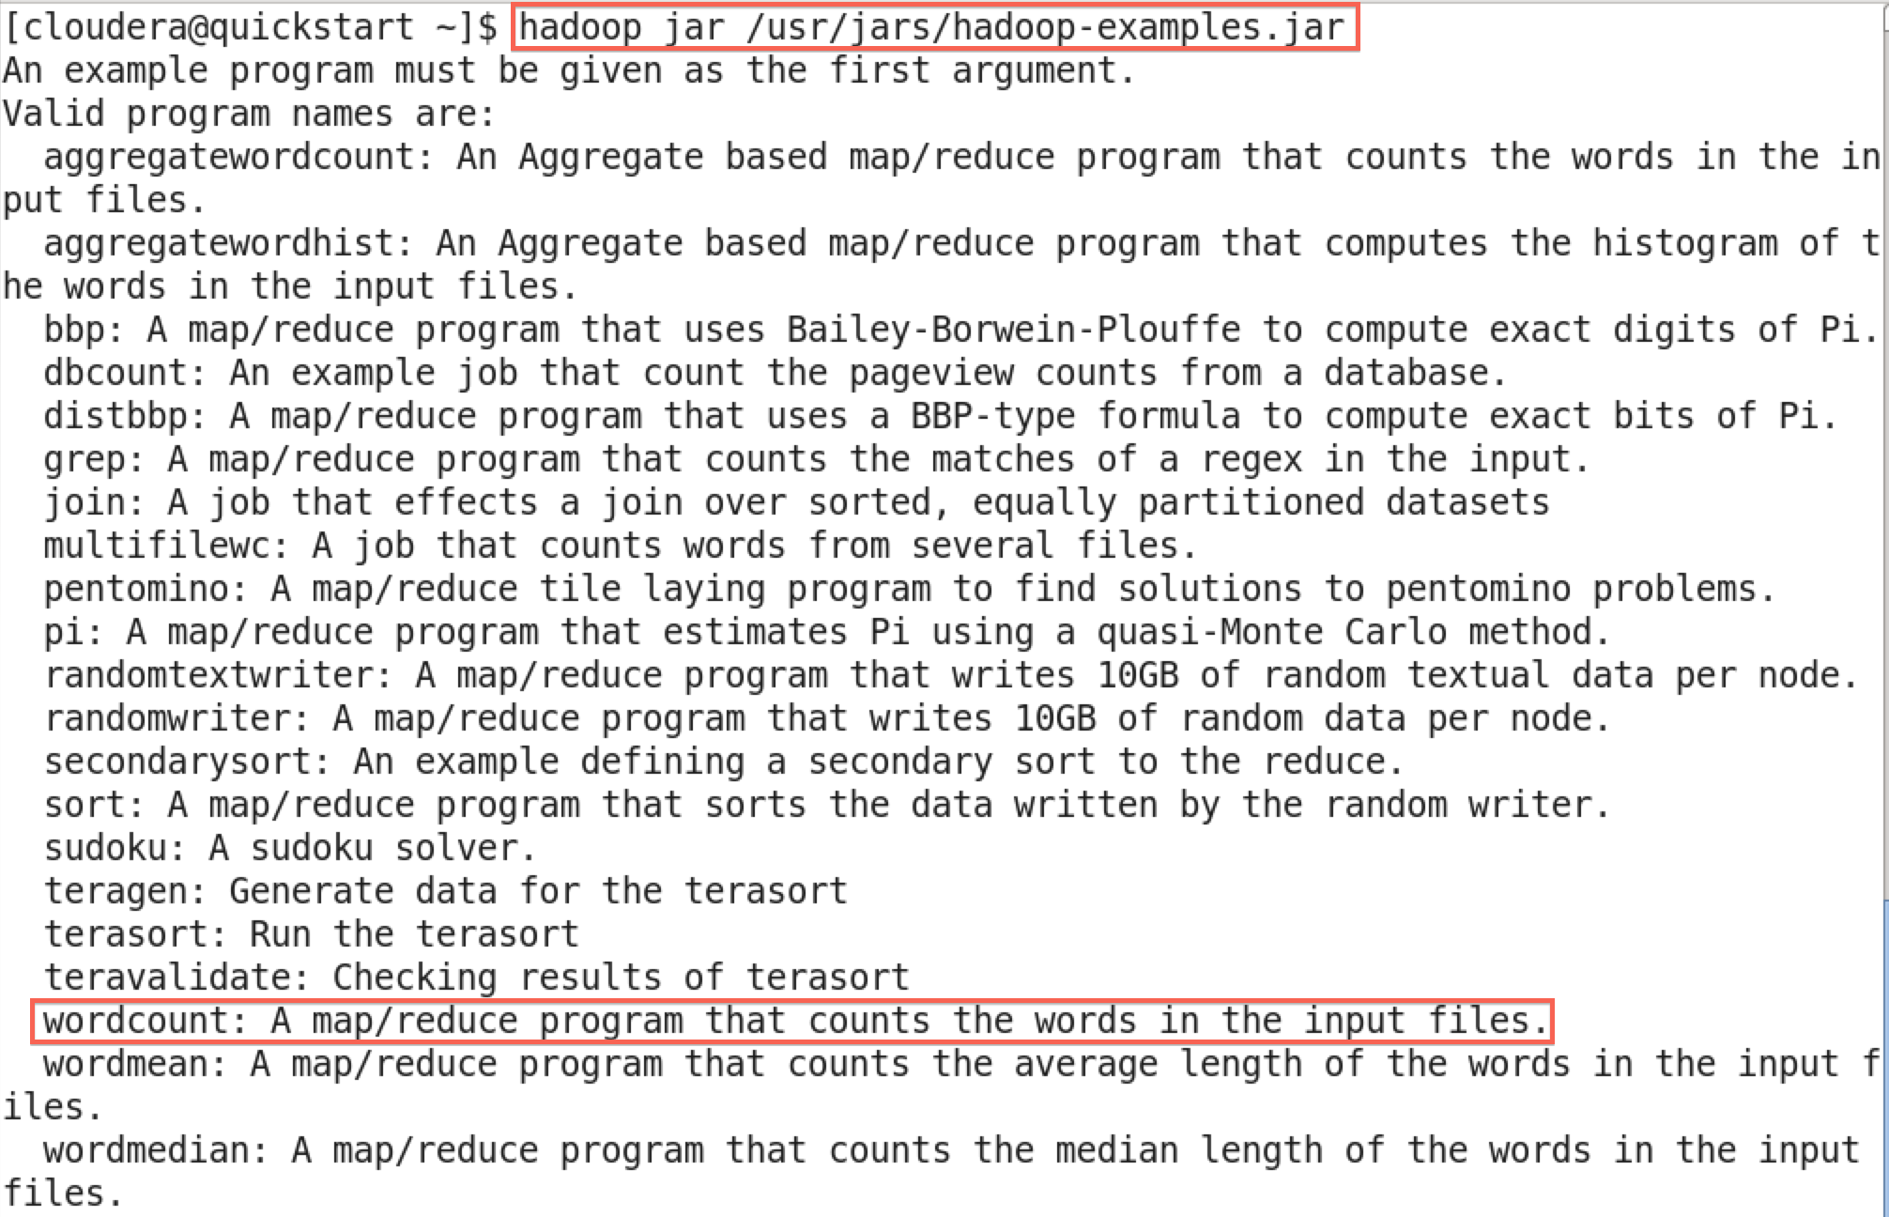

The output says that WordCount takes the name of one or more input files and the name of the output directory. Note that these files are in HDFS, not the local file system.
3. Verify input file exists. In the previous Reading, we downloaded the complete works of Shakespeare and copied them into HDFS. Let's make sure this file is still in HDFS so we can run WordCount on it. Run hadoopfs -ls
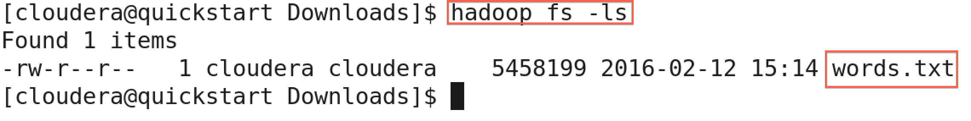
4. See WordCount command line arguments. We can learn how to run WordCount by examining its command-line arguments. Run hadoop jar /usr/jars/hadoop-examples.jar wordcount.

5. Run WordCount. Run WordCount for words.txt: hadoop jar /usr/jars/hadoop-examples.jar wordcount words.txt out
As WordCount executes, the Hadoop prints the progress in terms of Map and Reduce. When the WordCount is complete, both will say 100%.

6. See WordCount output directory. Once WordCount is finished, let's verify the output was created. First, let's see that the output directory, out, was created in HDFS by running hadoopfs –ls
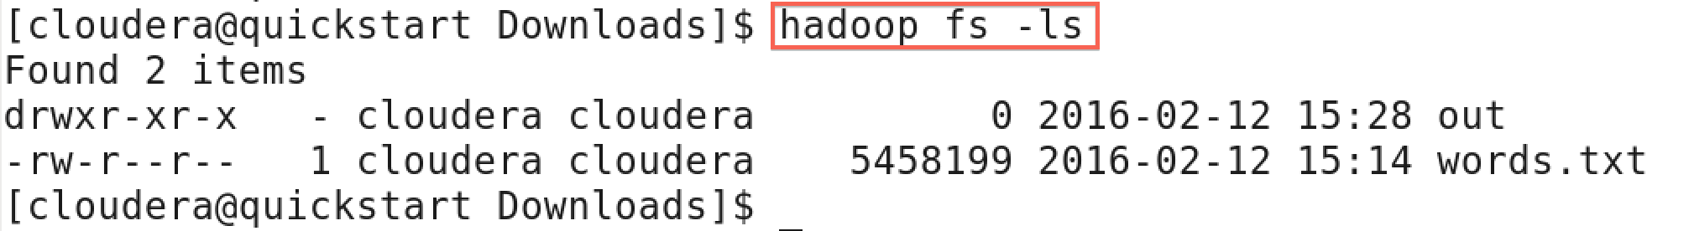
We can see there are now two items in HDFS: words.txt is the text file that we previously created, and out is the directory created by WordCount.
7. Look inside output directory. The directory created by WordCount contains several files. Look inside the directory by running hadoop –fsls out
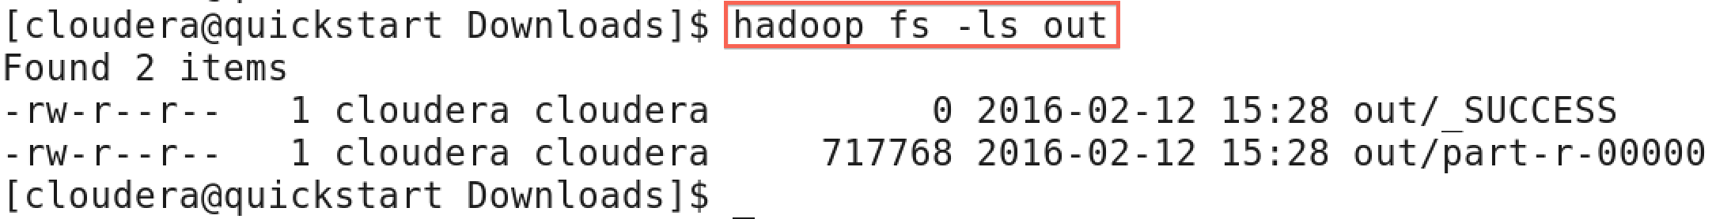
The file part-r-00000 contains the results from WordCount. The file _SUCCESS means WordCount executed successfully.
8. Copy WordCount results to local file system. Copy part-r-00000 to the local file system by running hadoopfs –copyToLocal out/part-r-00000 local.txt

9. View the WordCount results. View the contents of the results: more local.txt
Each line of the results file shows the number of occurrences for a word in the input file. For example, Accuse appears four times in the input, but Accusing appears only once.
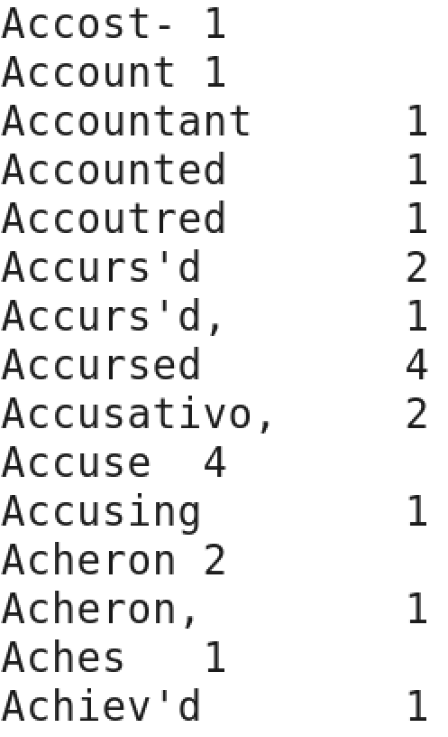

Experiment No.: 5
Name of Experiment: Write a Map Reduce program that mines weather data. Weather sensors collecting data everyhour at many locations across the globe gather a large
volume of log data, which is a goodcandidate for analysis with MapReduce,
since it is semi structured and record-oriented.
Steps to perform Experiment:
MapReduce Program – Weather Data Analysis For Analyzing Hot And Cold Days

Download the dataset - available on the NCEI website
https://www.ncei.noaa.gov/https://www.visualcrossing.com/resources/documentation/weathe
r-data-tutorials/how-to-download-weather-forecast-data-as-a-microsoft-excel-workbook/
**save this txt file in /home/cloudera directory**
Make a project in Eclipse with below steps:
1. Open Eclipse -> then select File -> New -> Java Project ->Name it WeatherProject
2. Then select use an execution environment -> choose JavaSE-1.7
1) Go on next​
2) In java setting -> select WeatherProject--Go in Libraries--add external Jars​
3) Go in file system--Go in usr--lib--hadoop--then select all jar files--click on ok
4) Again go in add jar files--hadoop-client--select all jar files--ok​
5) finish​
3. Now we are going to create a java file
1) Go in WeatherProject--src--right click-New-class-Name-MyMaxMin-finish
2) Write java code for analysis weatherdata in MyMaxMin class-Save it
4. Now export this java file:-
for this---go in file--export--select java--select jar file--next--select jar file specification--
select export destination--jar file--/home/cloudera/WeatherProject--finish
5. Copy weatherdata.txt file from download folder to / home/cloudera folder
6. go on terminal and write command.
1) hdfs dfs -ls /
(It will show List of directory and files in HDFS)
2) Now make a directory in hdfs with name "forweather"
3) Now copy weatherdata.txt file to HDFS by using put option
4) Command : hdfs dfs -put /home/cloudera/weatherdata.txt /forweather /
7. Now check file copied or not​
hdfs dfs -cat /forweather/weatherdata.txt /
8. Now compile :​
hadoop jar /home/cloudera/WeatherProject.jar MyMaxMin /forweather/weatherdata.txt
/weatherout /
9. Check weatherout directory (it will contain output file)
hdfs dfs -ls /weatherout
10. Run output file which contains result​
hdfc dfs -cat /weatherout/jaipur-r-00000
Resources:-

https://blog.eduonix.com/bigdata-and-hadoop/hadoop-project-on-ncdc-national-climate-data-
center-noaa-dataset/

https://www.geeksforgeeks.org/mapreduce-program-weather-data-analysis-for-analyzing-hot-
and-cold-days/
Program Code:
MyMaxMin.Java
// importing Libraries
import java.io.IOException;
import java.util.Iterator;
import org.apache.hadoop.fs.Path;
import org.apache.hadoop.io.LongWritable;
import org.apache.hadoop.io.Text;
import org.apache.hadoop.mapreduce.lib.input.FileInputFormat; import org.apache.hadoop.mapreduce.lib.output.FileOutputFormat; import org.apache.hadoop.mapreduce.lib.output.TextOutputFormat; import org.apache.hadoop.mapreduce.lib.input.TextInputFormat; import org.apache.hadoop.mapreduce.Job;
import org.apache.hadoop.mapreduce.Mapper;
import org.apache.hadoop.mapreduce.Reducer;
import org.apache.hadoop.conf.Configuration;
public class MyMaxMin {
// Mapper
/*MaxTemperatureMapper class is static
* and extends Mapper abstract class
* having four Hadoop generics type
* LongWritable, Text, Text, Text.
*/
public static class MaxTemperatureMapper extends Mapper<LongWritable, Text, Text, Text> {
/**
* @method map
* This method takes the input as a text data type.
* Now leaving the first five tokens, it takes
* 6th token is taken as temp_max and
* 7th token is taken as temp_min. Now * temp_max > 30 and temp_min < 15 are
* passed to the reducer.
*/
// the data in our data set with
// this value is inconsistent data
public static final int MISSING = 9999;
@Override
public void map(LongWritable arg0, Text Value, Context context) throws IOException, InterruptedException {
// Convert the single row(Record) to
// String and store it in String
// variable name line
String line = Value.toString();
// Check for the empty line
if (!(line.length() == 0)) {
// from character 6 to 14 we have
// the date in our dataset
String date = line.substring(6, 14);
// similarly we have taken the maximum
// temperature from 39 to 45 characters
float temp_Max = Float.parseFloat(line.substring(39, 45).trim());
// similarly we have taken the minimum
// temperature from 47 to 53 characters
float temp_Min = Float.parseFloat(line.substring(47, 53).trim());
// if maximum temperature is
// greater than 30, it is a hot day
if (temp_Max > 30.0) {
// Hot day
context.write(new Text("The Day is Hot Day :" + date),
new
Text(String.valueOf(temp_Max)));
}
// if the minimum temperature is
// less than 15, it is a cold day
if (temp_Min < 15) {
// Cold day
context.write(new Text("The Day is Cold Day :" + date),
new Text(String.valueOf(temp_Min)));
}
}
}
}
// Reducer
/*MaxTemperatureReducer class is static
and extends Reducer abstract class
having four Hadoop generics type
Text, Text, Text, Text.
*/
public static class MaxTemperatureReducer extends
Reducer<Text, Text, Text, Text> {
/**
* @method reduce
* This method takes the input as key and
* list of values pair from the mapper,
* it does aggregation based on keys and
* produces the final context.
*/
public void reduce(Text Key, Iterator<Text> Values, Context context) throws IOException, InterruptedException {
// putting all the values in
// temperature variable of type String
String temperature = Values.next().toString();
context.write(Key, new Text(temperature));
}
}
/**
* @method main
* This method is used for setting
* all the configuration properties.
* It acts as a driver for map-reduce
* code.
*/
public static void main(String[] args) throws Exception {
// reads the default configuration of the // cluster from the configuration XML files Configuration conf = new Configuration();
// Initializing the job with the // default configuration of the cluster Job job = new Job(conf, "weather example");
// Assigning the driver class name job.setJarByClass(MyMaxMin.class);
// Key type coming out of mapper job.setMapOutputKeyClass(Text.class);
// value type coming out of mapper job.setMapOutputValueClass(Text.class);
// Defining the mapper class name job.setMapperClass(MaxTemperatureMapper.class);
// Defining the reducer class name job.setReducerClass(MaxTemperatureReducer.class);
// Defining input Format class which is // responsible to parse the dataset // into a key value pair
job.setInputFormatClass(TextInputFormat.class);
// Defining output Format class which is // responsible to parse the dataset
// into a key value pair
job.setOutputFormatClass(TextOutputFormat.class);
// setting the second argument
// as a path in a path variable
Path OutputPath = new Path(args[1]);
// Configuring the input path
// from the filesystem into the job FileInputFormat.addInputPath(job, new Path(args[0]));
// Configuring the output path from // the filesystem into the job
FileOutputFormat.setOutputPath(job, new Path(args[1]));
// deleting the context path automatically // from hdfs so that we don't have // to delete it explicitly
OutputPath.getFileSystem(conf).delete(OutputPath);
// exiting the job only if the
// flag value becomes false
System.exit(job.waitForCompletion(true) ? 0 : 1);
}
}

Experiment No.: 6
Name of Experiment: Write a program that reads two words representing passwords from the java console and outputs the number of character in the smaller of the two. For example, if the words are open and sesame, then the output should be 4, the length of the shorter word, open. And test this program using JaButi.
Steps to perform Experiment:
Implement Matrix Multiplication with Hadoop Map Reduce
Make a project in Eclipse with below steps:
1. Open Eclipse -> then select File -> New -> Java Project ->Name it Matrix
2. Then select use an execution environment -> choose JavaSE-1.7
1) Go on next​
2) In java setting -> select Matrix--Go in Libraries--add external Jars​
3) Go in file system--Go in usr--lib--hadoop--then select all jar files--click on ok
4) Again go in add jar files--hadoop-client--select all jar files--ok​
5) finish​
3. Now we are going to create a java file
1) Go in Matrix--src--right click-New-class-Name-MatrixMultiply-finish; now write code for MatrixMultiply and save it.
2) Go in Matrix--src--right click-New-class-Name-Map- finish; now write code for Map and save it.
3) Go in Matrix--src--right click-New-class-Name-Reduce- finish; now write code for Reduce and save it.
4. Now export Matrix Project:-
for this---go in file--export--select java--select jar file--next--select jar file specification--
select export destination--jar file--/home/cloudera/MatrixMultiply.jar--finish
5. Now create two txt files:-
- First as m.txt(it is first matrix-make it 2X2)
Data in file m.txt:
M,0,0,1
M,0,1,2
M,1,0,3
M,1,1,4
- Second as n.txt(it is Second matrix-make it 2X2)
Data in file n.txt:
N,0,0,1
N,0,1,2
N,1,0,3
N,1,1,4
How we can create:- directly go on terminal write:
[cloudera@quickstart ~ ]$ pwd
/home/cloudera
[cloudera@quickstart ~ ]$ cat > m.txt
[cloudera@quickstart ~ ]$ cat > n.txt
6. go on terminal and write command.
1) hdfs dfs -ls /
(It will show List of directory and files in HDFS)
2) Now make a directory in hdfs with name "formatrix"
3) Now copy m.txt and n.txt file to HDFS by using put option
4) [cloudera@quickstart ~ ]$ hdfs dfs -put /home/cloudera/m.txt /formatrix /
[cloudera@quickstart ~ ]$ hdfs dfs -put /home/cloudera/n.txt /formatrix /
7. Now check file copied or not​
[cloudera@quickstart ~ ]$ hdfs dfs -cat /formatrix/m.txt /
[cloudera@quickstart ~ ]$ hdfs dfs -cat /formatrix/n.txt /
These two commands will show data of above two file m.txt and n.txt
8. Now compile:​
[cloudera@quickstart ~ ]$ hadoop jar /home/cloudera/MatrixMultiply.jar MatrixMultiply /formatrix/* /matrixout /
Program will be compile by above step (if error occurs than remove that first)
9. Check matrixout directory (it will contain output file)
[cloudera@quickstart ~ ]$ hdfs dfs -ls / matrixout
Found 2 items
-rw-r--r-- 1 cloudera supergroup 0 2021-05-19 21:23 / matrixout /_SUCCESS
-rw-r--r-- 1 cloudera supergroup 35 2021-05-19 21:23 / matrixout /part-r-00000
10. Run output file which contains result​
hdfc dfs -cat / matrixout / part-r-00000
0,0,7.0
0,1,10.0
1,0,15.0
1,1,22.0
Program Code:
MatrixMultiply.java

import org.apache.hadoop.conf.*;
import org.apache.hadoop.fs.Path;
import org.apache.hadoop.io.*;
import org.apache.hadoop.mapreduce.*;
import org.apache.hadoop.mapreduce.lib.input.FileInputFormat;
import org.apache.hadoop.mapreduce.lib.input.TextInputFormat;
import org.apache.hadoop.mapreduce.lib.output.FileOutputFormat;
import org.apache.hadoop.mapreduce.lib.output.TextOutputFormat;

public class MatrixMultiply {

public static void main(String[] args) throws Exception {
if (args.length != 2) {
System.err.println("Usage: MatrixMultiply <in_dir> <out_dir>");
System.exit(2);
}
Configuration conf = new Configuration();
// M is an m-by-n matrix; N is an n-by-p matrix.
conf.set("m", "1000");
conf.set("n", "100");
conf.set("p", "1000");
@SuppressWarnings("deprecation")
Job job = new Job(conf, "MatrixMultiply");
job.setJarByClass(MatrixMultiply.class);
job.setOutputKeyClass(Text.class);
job.setOutputValueClass(Text.class);

job.setMapperClass(Map.class);
job.setReducerClass(Reduce.class);

job.setInputFormatClass(TextInputFormat.class);
job.setOutputFormatClass(TextOutputFormat.class);

FileInputFormat.addInputPath(job, new Path(args[0]));
FileOutputFormat.setOutputPath(job, new Path(args[1]));

job.waitForCompletion(true);
}

Reduce
import org.apache.hadoop.io.Text;
import org.apache.hadoop.mapreduce.Reducer;

import java.io.IOException;
import java.util.HashMap;

public class Reduce
extends org.apache.hadoop.mapreduce.Reducer<Text, Text, Text, Text> {
@Override
public void reduce(Text key, Iterable<Text> values, Context context)
throws IOException, InterruptedException {
String[] value;
//key=(i,k),
//Values = [(M/N,j,V/W),..]
HashMap<Integer, Float> hashA = new HashMap<Integer, Float>();
HashMap<Integer, Float> hashB = new HashMap<Integer, Float>();
for (Text val : values) {
value = val.toString().split(",");
if (value[0].equals("M")) {
hashA.put(Integer.parseInt(value[1]), Float.parseFloat(value[2]));
} else {
hashB.put(Integer.parseInt(value[1]), Float.parseFloat(value[2]));
}
}
int n = Integer.parseInt(context.getConfiguration().get("n"));
float result = 0.0f;
float m_ij;
float n_jk;
for (int j = 0; j < n; j++) {
m_ij = hashA.containsKey(j) ? hashA.get(j) : 0.0f;
n_jk = hashB.containsKey(j) ? hashB.get(j) : 0.0f;
result += m_ij * n_jk;
}
if (result != 0.0f) {
context.write(null,
new Text(key.toString() + "," + Float.toString(result)));
}
}
}
Mapper
import org.apache.hadoop.conf.*;
import org.apache.hadoop.io.LongWritable;
import org.apache.hadoop.io.Text;
import org.apache.hadoop.mapreduce.Mapper;

import java.io.IOException;

public class Map
extends org.apache.hadoop.mapreduce.Mapper<LongWritable, Text, Text, Text> {
@Override
public void map(LongWritable key, Text value, Context context)
throws IOException, InterruptedException {
Configuration conf = context.getConfiguration();
int m = Integer.parseInt(conf.get("m"));
int p = Integer.parseInt(conf.get("p"));
String line = value.toString();
// (M, i, j, Mij);
String[] indicesAndValue = line.split(",");
Text outputKey = new Text();
Text outputValue = new Text();
if (indicesAndValue[0].equals("M")) {
for (int k = 0; k < p; k++) {
outputKey.set(indicesAndValue[1] + "," + k);
// outputKey.set(i,k);
outputValue.set(indicesAndValue[0] + "," + indicesAndValue[2]
+ "," + indicesAndValue[3]);
// outputValue.set(M,j,Mij);
context.write(outputKey, outputValue);
}
} else {
// (N, j, k, Njk);
for (int i = 0; i < m; i++) {
outputKey.set(i + "," + indicesAndValue[2]);
outputValue.set("N," + indicesAndValue[1] + ","
+ indicesAndValue[3]);
context.write(outputKey, outputValue);
}
}
}
}

Experiment No.: 7
Experiment-7
Install and Run Pig then write Pig Latin scripts to sort, group, join, project, and filter
your data.
7(a) Install and Run Pig on wordcount
7(b) Write Pig Latin scripts to sort, group, join, project, and filter your data.
Phase:-1 Installation of Pig
1. Open cloudera on virtual box
2. Open browser
3. Click on Hue- Web application developed by cloudera
4. Login with use id and password as cloudera
5. Click on Manage HDFS
6. By default in user/cloudera folder
7. Create folder as Sec-A/Pig
8. Create file WordCount.txt- save it
9. Open terminal – write pig on command prompt to start pig
Phase: 2
1) Working with Grunt shell
2) Create word count application
3) Execute word count application
4) Accessing HDFS from grunt shell
Step 1 : Start Grunt shell.

Open terminal and type pig
Step 1A : Create a file at /user/cloudera/Sec-A/Pig/WordCount.txt with following
content.
I am learning Pig Using HadoopExam
I am learning Spark Using HadoopExam
I am learning Java Using HadoopExam
I am learning Hadoop Using HadoopExam
Step 2 : Now load the file stored in hdfs (Space separated file)
input1 = LOAD &#39;/user/cloudera/Sec-A/Pig/WordCount.txt &#39; AS (f1:chararray);
DUMP input1;
(I am learning Pig Using HadoopExam)
(I am learning Spark Using HadoopExam)
(I am learning Java Using HadoopExam)
(I am learning Hadoop Using HadoopExam)
Step 3: flatten the words in each line
wordsInEachLine = FOREACH input1 GENERATE flatten(TOKENIZE(f1)) as word;
DUMP wordsInEachLine;

Step 4: Group the same words
groupedWords = group wordsInEachLine by word;
dump groupedWords;
describe groupedWords;
Step 5 : Now do the wordcount.
countedWords = foreach groupedWords generate group, COUNT(wordsInEachLine);
dump countedWords;

More About PigLatin :
• Pig scripts can be a linear workflow (As shown above in word count example)
• Pig Scripts can have branching like multiple data inputs are joined (De-normalizing)
and data splitting etc.
• In Pig latin scripts , you will not find if statements and for loop (This is simply a DAG
: Direct Acyclic Graph)
Grunt : It is a shell, where we have been writing our Pig scripts. Generally production code
will be written in a separate file. But while writing we want to test our scripts with test data,
hence we will be using Grunt shell for prototyping our script.
Remember :
• It provides Tab completion of commands (Not file name as in shell scripts)
• Ctrl+D will help you to come out of Grunt
Dump and Store : Pig Latin will not execute scripts until it sees Dump or Store command ,
as we have done in our example.
Accessing HDFS : You can use hdfs commands inside Grunt shell as below
&gt; fs -ls

7(b) Topic: -Pig Latin scripts to sort, group, join, project, and filter your data.
Apache Pig - Group Operator
student_details = LOAD &#39;/user/cloudera/Sec-A/Pig/student_details.txt&#39; USING PigStorage(&#39;,&#39;) as
(id:int, firstname:chararray, lastname:chararray, age:int, phone:chararray, city:chararray);
group_data = GROUP student_details by age;
Dump group_data;
Output:
(21,{(4,Preethi,Agarwal,21,9848022330,Pune ),(1,Rajiv,Reddy,21,9848022337,Hyderabad)})
(22,{(3,Rajesh,Khanna,22,9848022339,Delhi
),(2,siddarth,Battacharya,22,9848022338,Kolkata)})
(23,{(6,Archana,Mishra,23,9848022335,Chennai
),(5,Trupthi,Mohanthy,23,9848022336,Bhuwaneshwar )})
(24,{(8,Bharathi,Nambiayar,24,9848022333,Chennai),(7,Komal,Nayak,24,9848022334,trivend
ram )})
Grouping by Multiple Columns
group_multiple = GROUP student_details by (age, city);
Dump group_multiple;
Output:
((21,Pune ),{(4,Preethi,Agarwal,21,9848022330,Pune )})
((21,Hyderabad),{(1,Rajiv,Reddy,21,9848022337,Hyderabad)})
((22,Delhi ),{(3,Rajesh,Khanna,22,9848022339,Delhi )})
((22,Kolkata),{(2,siddarth,Battacharya,22,9848022338,Kolkata)})
((23,Chennai ),{(6,Archana,Mishra,23,9848022335,Chennai )})
((23,Bhuwaneshwar ),{(5,Trupthi,Mohanthy,23,9848022336,Bhuwaneshwar )})
((24,Chennai),{(8,Bharathi,Nambiayar,24,9848022333,Chennai)})
((24,trivendram ),{(7,Komal,Nayak,24,9848022334,trivendram )})
Join
customers = LOAD &#39;/user/cloudera/Sec-A/Pig/customers.txt&#39; USING PigStorage(&#39;,&#39;) as (id:int,
name:chararray, age:int, address:chararray, salary:int);
orders = LOAD &#39;/user/cloudera/Sec-A/Pig/orders.txt&#39; USING PigStorage(&#39;,&#39;) as (oid:int,
date:chararray, customer_id:int, amount:int);
Self Join:
customers1 = LOAD &#39;/user/cloudera/Sec-A/Pig/customers.txt&#39; USING PigStorage(&#39;,&#39;) as (id:int,
name:chararray, age:int, address:chararray, salary:int);
customers2 = LOAD &#39;/user/cloudera/Sec-A/Pig/customers.txt&#39; USING PigStorage(&#39;,&#39;) as (id:int,
name:chararray, age:int, address:chararray, salary:int);
customers3 = JOIN customers1 BY id, customers2 BY id;
Dump customers3;

Output:
(1,Ramesh,32,Ahmedabad,2000,1,Ramesh,32,Ahmedabad,2000)
(2,Khilan,25,Delhi,1500,2,Khilan,25,Delhi,1500)
(3,kaushik,23,Kota,2000,3,kaushik,23,Kota,2000)
(4,Chaitali,25,Mumbai,6500,4,Chaitali,25,Mumbai,6500)
(5,Hardik,27,Bhopal,8500,5,Hardik,27,Bhopal,8500)
(6,Komal,22,MP,4500,6,Komal,22,MP,4500)
(7,Muffy,24,Indore,10000,7,Muffy,24,Indore,10000)
Inner Join:
coustomer_orders = JOIN customers BY id, orders BY customer_id;
Dump coustomer_orders;
Output:
(2,Khilan,25,Delhi,1500,101,2009-11-20 00:00:00,2,1560)
(3,kaushik,23,Kota,2000,100,2009-10-08 00:00:00,3,1500)
(3,kaushik,23,Kota,2000,102,2009-10-08 00:00:00,3,3000)
(4,Chaitali,25,Mumbai,6500,103,2008-05-20 00:00:00,4,2060)
Outer Join:
Left Outer Join:
outer_left = JOIN customers BY id LEFT OUTER, orders BY customer_id;
Dump outer_left;
Output:
(1,Ramesh,32,Ahmedabad,2000,,,,)
(2,Khilan,25,Delhi,1500,101,2009-11-20 00:00:00,2,1560)
(3,kaushik,23,Kota,2000,100,2009-10-08 00:00:00,3,1500)
(3,kaushik,23,Kota,2000,102,2009-10-08 00:00:00,3,3000)
(4,Chaitali,25,Mumbai,6500,103,2008-05-20 00:00:00,4,2060)
(5,Hardik,27,Bhopal,8500,,,,)
(6,Komal,22,MP,4500,,,,)
(7,Muffy,24,Indore,10000,,,,)
Right Outer Join:
outer_right = JOIN customers BY id RIGHT, orders BY customer_id;
Dump outer_right
Output:
(2,Khilan,25,Delhi,1500,101,2009-11-20 00:00:00,2,1560)
(3,kaushik,23,Kota,2000,100,2009-10-08 00:00:00,3,1500)
(3,kaushik,23,Kota,2000,102,2009-10-08 00:00:00,3,3000)
(4,Chaitali,25,Mumbai,6500,103,2008-05-20 00:00:00,4,2060)

Full Outer Join
outer_full = JOIN customers BY id FULL OUTER, orders BY customer_id;
Dump outer_full;

Output
(1,Ramesh,32,Ahmedabad,2000,,,,)
(2,Khilan,25,Delhi,1500,101,2009-11-20 00:00:00,2,1560)
(3,kaushik,23,Kota,2000,100,2009-10-08 00:00:00,3,1500)
(3,kaushik,23,Kota,2000,102,2009-10-08 00:00:00,3,3000)
(4,Chaitali,25,Mumbai,6500,103,2008-05-20 00:00:00,4,2060)
(5,Hardik,27,Bhopal,8500,,,,)
(6,Komal,22,MP,4500,,,,)
(7,Muffy,24,Indore,10000,,,,)

Apache Pig - Filter Operator
student_details = LOAD &#39;/user/cloudera/Sec-A/Pig/student_details.txt&#39; USING PigStorage(&#39;,&#39;) as
(id:int, firstname:chararray, lastname:chararray, age:int, phone:chararray, city:chararray);
filter_data = FILTER student_details BY city == &#39;Chennai&#39;;
Dump filter_data;
Output:
(8,Bharathi,Nambiayar,24,9848022333,Chennai)

Experiment No.: 8
Objective: Install and Run Hive then use Hive to create, alter, and drop databases, tables, views, functions, and indexes.

Hive is pre-installed in cloudera framework.

Step
- Open Terminal – run command hive---enter
- In Hive mode now

hive>
- To create Database:-
hive> CREATE DATABASE user;
OK
Time taken: 4.478 seconds

- Show database in hive:-
hive> show databases;
OK
default
user
Time taken: 0.77 seconds, Fetched: 2 row(s)

- Drop Database:-
hive> DROP DATABASE IF EXISTS user;
OK
Time taken: 0.751 seconds

- Create Table:-
hive> CREATE TABLE IF NOT EXISTS employee (eid int,name String,salary String,destination String)
> COMMENT 'Employee details'
> ROW FORMAT DELIMITED
> FIELDS TERMINATED BY '\t'
> LINES TERMINATED BY '\n'
> STORED AS TEXTFILE;
OK
Time taken: 2.316 seconds

- Show Tables:-
hive>show table;
OK
emp
Time taken: 0.77 seconds, Fetched: 1 row(s)
- Create txt file in /home/cloudera/hive/sample.txt.
+write data in file

- Load data in emp table:
hive> LOAD DATA LOCAL INPATH '/home/cloudera/hive/sample.txt' OVERWRITE INTO TABLE emp;
Loading data to table default.emp
Table default.emp stats: [numFiles=1, numRows=0, totalSize=201, rawDataSize=0]
OK
Time taken: 1.409 seconds

- Hive - Alter Table
The statement takes any of the following syntaxes based on what attributes we wish to modify in a table.

ALTER TABLE name RENAME TO new_name
ALTER TABLE name ADD COLUMNS (col_spec[, col_spec ...])
ALTER TABLE name DROP [COLUMN] column_name
ALTER TABLE name CHANGE column_name new_name new_type
ALTER TABLE name REPLACE COLUMNS (col_spec[, col_spec ...])

- The following query renames the table from employee to emp.

hive> ALTER TABLE employee RENAME TO emp;
OK
Time taken: 0.23 seconds
hive> show tables;
OK
emp
p
patients
prescription
Time taken: 0.05 seconds, Fetched: 4 row(s)

- Change Statement
Change column name:-
hive> ALTER TABLE emp CHANGE name ename String;
OK
Time taken: 5.781 seconds

- Change type of column:-
hive> ALTER TABLE emp CHANGE salary salary Double;
OK
Time taken: 0.269 seconds

- To add new column in table:-
This query adds a column named dept to the emp table.
hive> ALTER TABLE emp ADD COLUMNS (dept STRING COMMENT 'Department name');
OK
Time taken: 0.281 seconds

- Replace Statement:
This query deletes all the columns from the emp table and replaces it with emp and name columns:

hive> ALTER TABLE emp REPLACE COLUMNS (eid INT empid Int,ename STRING name String);

- Drop Table Statement:-

This query drops a table named employee:

hive> DROP TABLE IF EXISTS emp;

- To create data randomly use www.generatedata.com, to see how it will work use my recorded video on teams.

https://poornimauniversity.sharepoint.com/sites/PIET_CS_VIIISEMSECTIONB/Shared%20Documents/BIG%20DATA%20ANALYTICS%20LAB/Recordings/Experiment-8-20210605_091115-Meeting%20Recording.mp4?web=1

